<https://www.prajwaldesai.com/deploying-adobe-reader-updates-using-sccm-2012-r2/>

**Deploying Adobe Reader Updates Using SCCM 2012 R2**

First we will create a package for Adobe Reader 11.0.02 and deploy it to a collection. If you know how to create a package and deploy you can skip the below step. In the SCCM console, click on **Software Library**, click **Application Management**. Right click on **Packages** and click **Create Package**. Provide the **Name**, **Source Folder** for the package and click **Next**.

[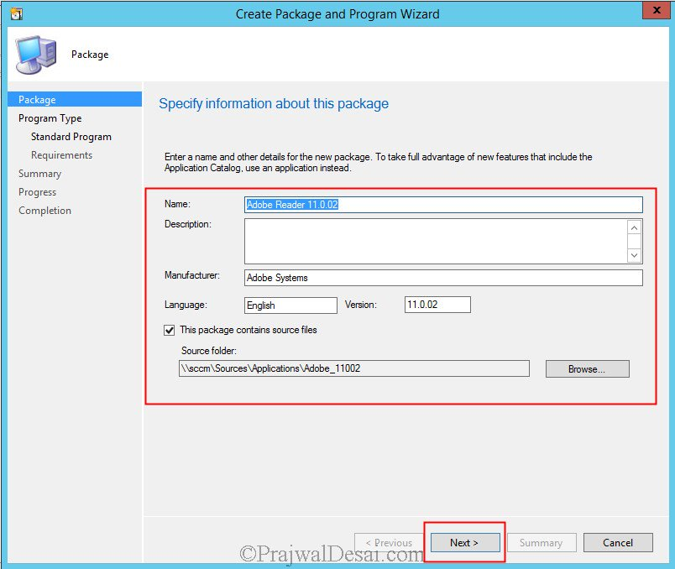](http://prajwaldesai.com/wp-content/uploads/2014/04/Deploying-Adobe-Reader-Updates-Using-SCCM-2012-R2-Snap1.jpg)

Choose the **Program Type** as **Standard program**. Click **Next**.

[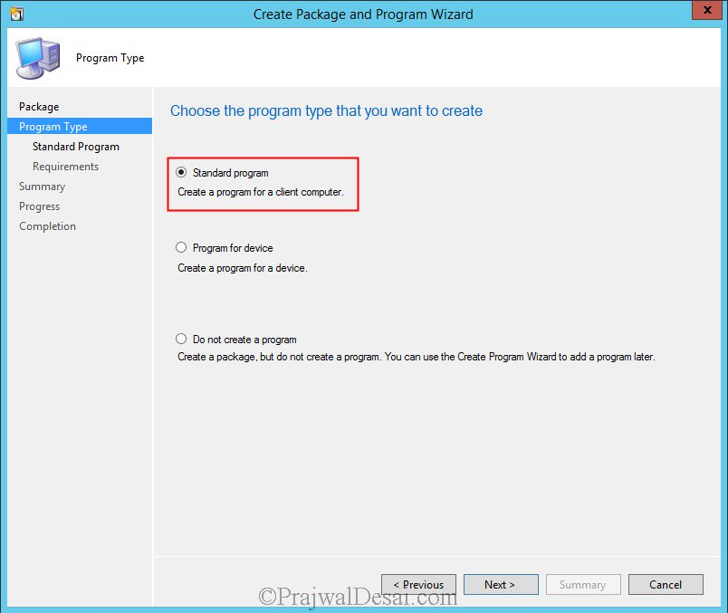](http://prajwaldesai.com/wp-content/uploads/2014/04/Deploying-Adobe-Reader-Updates-Using-SCCM-2012-R2-Snap2.jpg)

Specify the information about the program as shown in the below screenshot. Click **Next**.

[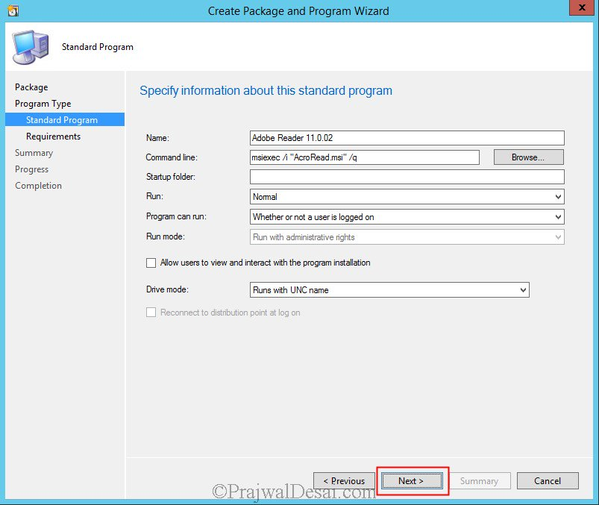](http://prajwaldesai.com/wp-content/uploads/2014/04/Deploying-Adobe-Reader-Updates-Using-SCCM-2012-R2-Snap3.jpg)

Complete the **Create Package and Program Wizard** and click **Close**. The next step is to distribute the Adobe Reader Program to the distribution point and deploy it to the collection. To distribute the program, right click on the program and click **Distribute Content,**follow the wizard and wait till the content status color shows green. After that right click the program and deploy it to the collection.

[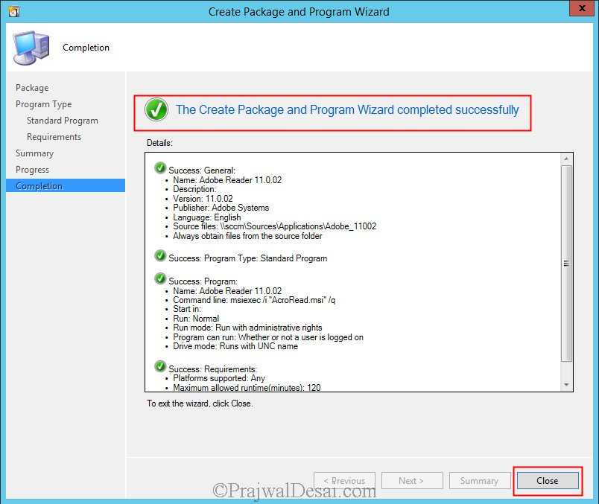](http://prajwaldesai.com/wp-content/uploads/2014/04/Deploying-Adobe-Reader-Updates-Using-SCCM-2012-R2-Snap4.jpg)

After you have deployed the Adobe Reader software to the collections, the next step is deploying adobe reader updates using SCCM 2012 R2. In the above example we had deployed Adobe Reader 11.0.02 to client systems, now what if there is a new version of Adobe Reader?.

We have the latest version of **Adobe reader 11.0.06** which can be downloaded from [here](ftp://ftp.adobe.com/pub/adobe/reader/win/). But since you have already deployed Adobe Reader 11.0.02 to the client systems it makes no sense to deploy 11.0.06 over it again. So we will now deploy only the update patch which will update Adobe Reader 11.0.02 to 11.0.06.

Download the latest version of Adobe Reader from [here](ftp://ftp.adobe.com/pub/adobe/reader/win/)and extract the executable using the command line **AdbeRdr11006_en_US.exe -nos_o”E:SourcesApplicationsAdobe_11″ -nos_ne**(where **AdbeRdr11006_en_US.exe** is the executable name, **E:SourcesApplicationsAdobe_11** is the path were the executable is stored).

Note – If you extract the Adobe Reader executable using winrar or any third party software you will not see .msp files. You have to extract it using a command line.

[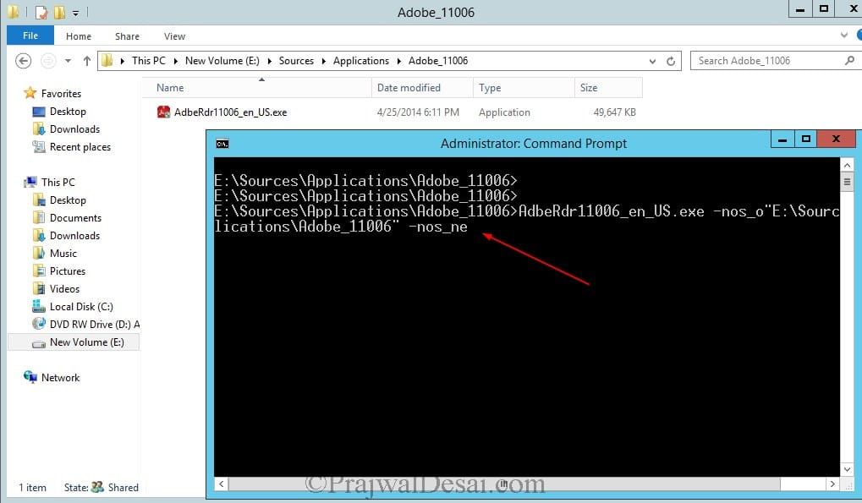](http://prajwaldesai.com/wp-content/uploads/2014/04/Deploying-Adobe-Reader-Updates-Using-SCCM-2012-R2-Snap5.jpg)

After we extract the setup file we see that it contains the update .msp file named **AdbeRdrUpd110006.msp.**This is the update file that we will be deploying using SCCM and this will update the existing adobe reader 11.0.02 version to 11.0.06 version.

**YOU MAY ALSO LIKE**

[Configuring Client Settings in Configuration Manager 2012 R2](https://www.prajwaldesai.com/configuring-client-settings-in-configuration-manager-2012-r2/)

Dec 14, 2013

[Configuration Manager 1906 Hotfix KB4529827](https://www.prajwaldesai.com/configuration-manager-1906-hotfix-kb4529827/)

Nov 29, 2019

[Change Intune Primary User of Windows Device](https://www.prajwaldesai.com/change-intune-primary-user-of-windows-device/)

Apr 21, 2020

[How to deploy Lync 2013 client using SCCM](https://www.prajwaldesai.com/how-to-deploy-lync-2013-client-using-sccm/)

May 25, 2016

[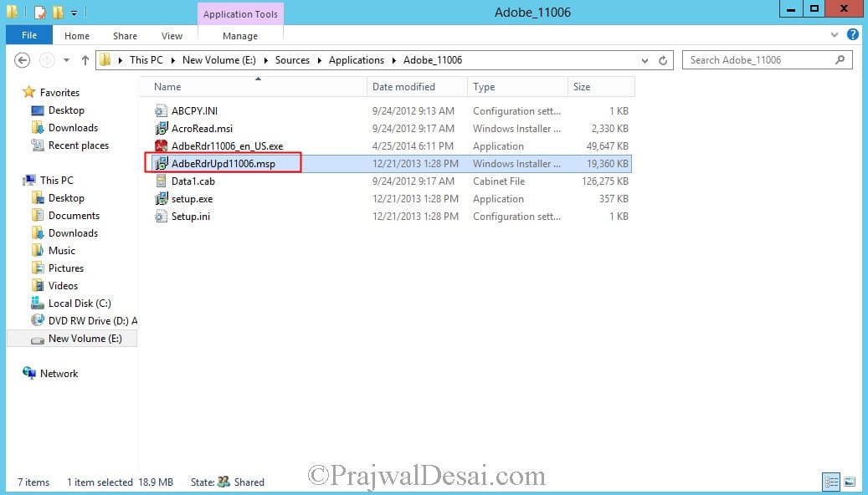](http://prajwaldesai.com/wp-content/uploads/2014/04/Deploying-Adobe-Reader-Updates-Using-SCCM-2012-R2-Snap6.jpg)

Copy the **AdbeRdrUpd110006.msp**to the folder where Adobe 11.0.02 files exists.

[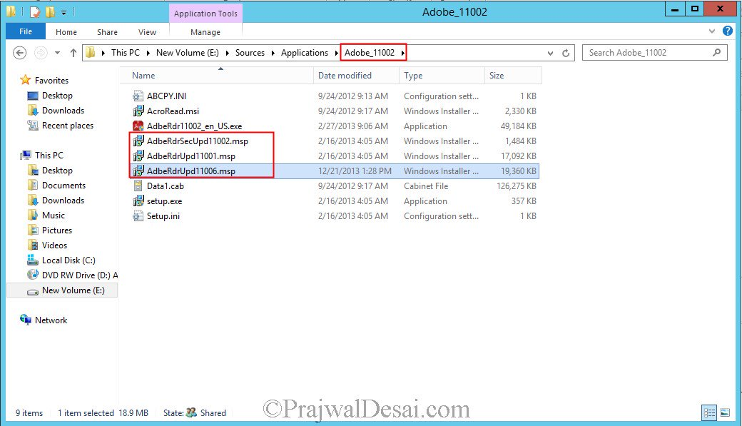](http://prajwaldesai.com/wp-content/uploads/2014/04/Deploying-Adobe-Reader-Updates-Using-SCCM-2012-R2-Snap7.jpg)

Right click on **Packages** and click **Create Package**. Provide the **Name**, **Source Folder** for the package and click **Next**.

[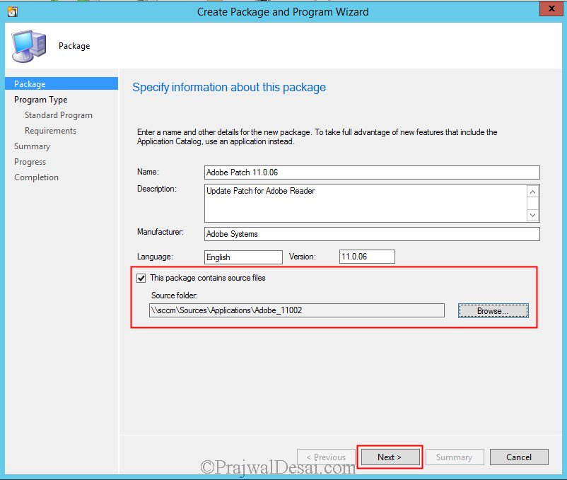](http://prajwaldesai.com/wp-content/uploads/2014/04/Deploying-Adobe-Reader-Updates-Using-SCCM-2012-R2-Snap8.jpg)

Choose the **Program Type** as **Standard program**. Click **Next**.

[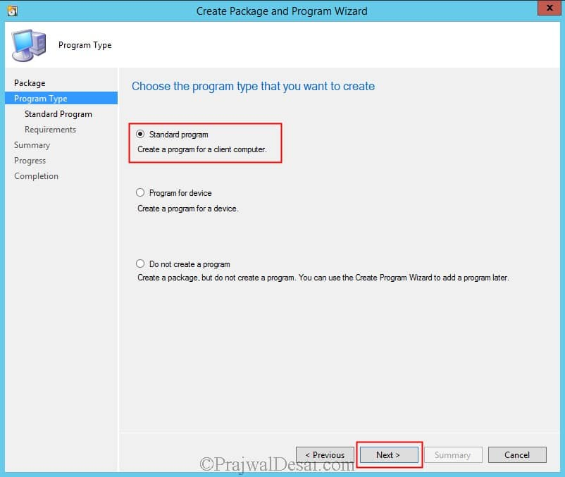](http://prajwaldesai.com/wp-content/uploads/2014/04/Deploying-Adobe-Reader-Updates-Using-SCCM-2012-R2-Snap9.jpg)

Syntax – “**msiexec /update msipatchname.msp /qn (OR) msiexec /p msipatchname.msp /qn**

Specify the name for the program, enter the command line **msiexec /p AdbeRdrUpd110006.msp /qn** and click **Next**.

[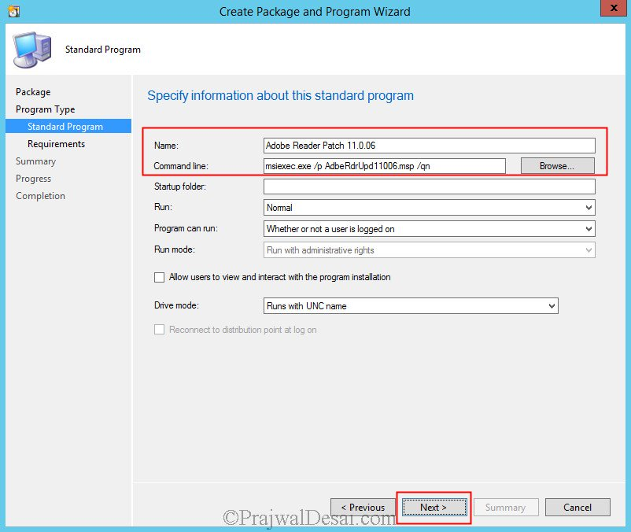](http://prajwaldesai.com/wp-content/uploads/2014/04/Deploying-Adobe-Reader-Updates-Using-SCCM-2012-R2-Snap10.jpg)

We now see that the Adobe Patch package is created. Right the package and distribute the content to the DP. Once the content status of the package shows green deploy it the collections.

[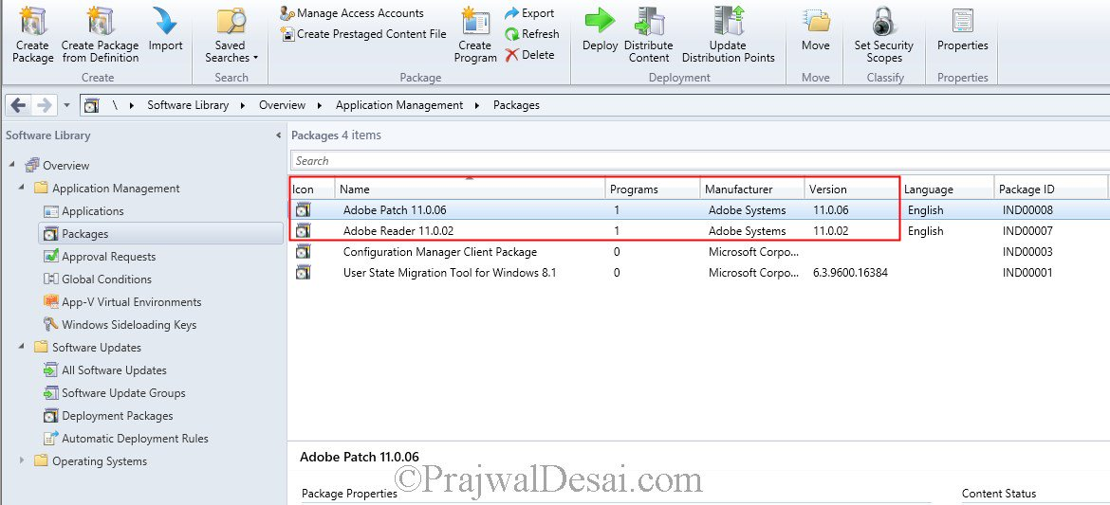](http://prajwaldesai.com/wp-content/uploads/2014/04/Deploying-Adobe-Reader-Updates-Using-SCCM-2012-R2-Snap11.jpg)

On one the client machine we open the **execmgr.log** file and we see that the patch file is being downloaded and installed.

[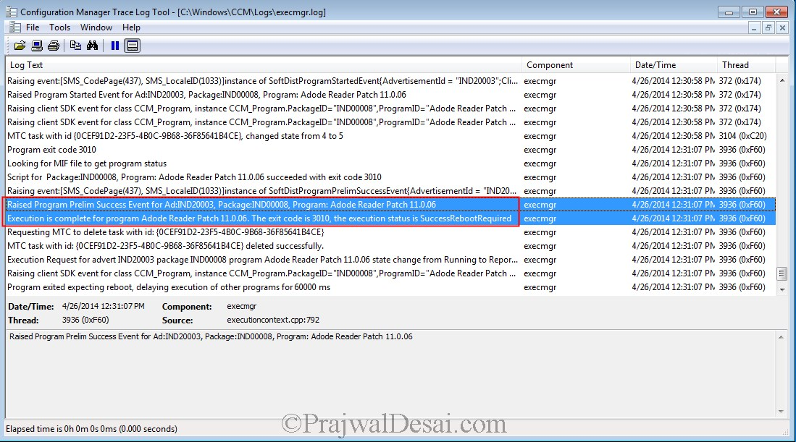](http://prajwaldesai.com/wp-content/uploads/2014/04/Deploying-Adobe-Reader-Updates-Using-SCCM-2012-R2-Snap12.jpg)

After few minutes we see that the Adobe Reader is updated to version 11.0.06.

[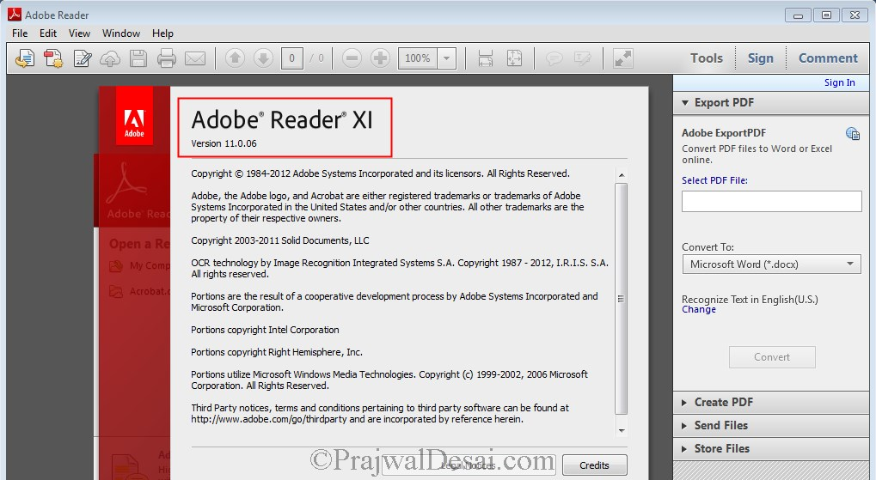](http://prajwaldesai.com/wp-content/uploads/2014/04/Deploying-Adobe-Reader-Updates-Using-SCCM-2012-R2-Snap13.jpg)